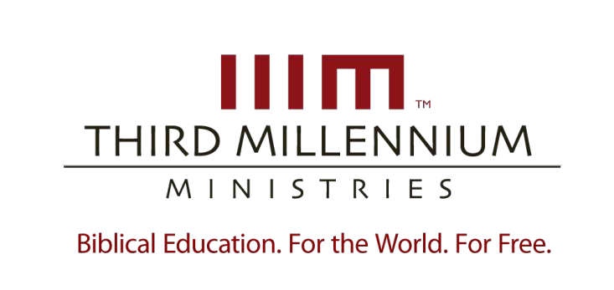

We Believe in the Holy Spirit

Essay Questions

ONE IN THE TRINITY
LESSON

For videos, manuscripts, and other resources, visit Third Millennium Ministries at thirdmill.org.

Essay Questions

- Define the term “pneumatology” in both a broad sense and in Christian theology. Why did the doctrine of the Holy Spirit as a distinct, uncreated person of the Trinity take so long to develop?

- List and explain several names the Old Testament uses to refer to God’s Spirit.

- The lesson discusses four characteristics of God’s Spirit in the Old Testament that point to his divinity. Select one of these characteristics, and describe in detail how this characteristic indicates the Spirit’s divinity. Cite specific Scripture references to support your answer.

- How does the Old Testament point to the personhood of the Holy Spirit? Include references from Scripture to support your answer.

- Describe what Jesus directly taught about the Holy Spirit during his earthly ministry. Explain why the Jews of his day were so offended by these teachings.

- Using specific examples from Scripture, demonstrate several ways that the apostles affirmed the Spirit’s full divinity and personhood.

- How does the Apostles’ Creed reflect the early church’s belief that the Holy Spirit is a third distinct person within the uncreated Godhead?

- How did the traditional definition of “Trinity” develop? Describe two of the opposing views that led up to this definition.

- The original Nicene Creed, written in A.D. 325, said very little about the Holy Spirit. What changes did the First Council of Constantinople make to the Creed in
A.D. 381, and how did this affect the church’s liturgy and worship?

- Describe both the “ontological Trinity” and the “economic Trinity.” How do these two perspectives help us understand the nature of the Spirit’s relationship to the Father and the Son?

1

© 2013 by Third Millennium Ministries www.thirdmill.org

We Believe in the Holy Spirit

Essay Questions

TWO IN THE WORLD
LESSON

For videos, manuscripts, and other resources, visit Third Millennium Ministries at thirdmill.org.

Essay Questions

- List the 6 days of creation and describe the work the Spirit accomplished each day.

- What is “providence”? Give some biblical examples of the Spirit’s providential work in nature.

© 2013 by Third Millennium Ministries www.thirdmill.org

- How does the Holy Spirit providentially work in humanity? Include references from Scripture to support your answer.

- The lesson discusses five common models theologians have used to categorize the Holy Spirit’s work of revelation. Identify and summarize each model, including the strengths and weaknesses (if any) of each.

- What does the Bible say about the Holy Spirit’s role as the source of revelation? List and describe three types of revelation that the Bible explicitly attributes to the Holy Spirit.

- Give some examples of the Holy Spirit’s work of promoting goodness, and explain how the Holy Spirit’s work of promoting goodness is an act of common grace. Use Scripture to support your answer.

- What are some ways that unbelievers benefit from the Holy Spirit’s work of promoting life?

1

© 2013 by Third Millennium Ministries www.thirdmill.org

We Believe in the Holy Spirit

Essay Questions

THREE IN THE CHURCH
LESSON

For videos, manuscripts, and other resources, visit Third Millennium Ministries at thirdmill.org.

Essay Questions

- Describe both the Old Testament church and the New Testament church and their relationship to one another.

- What are some of the ways that God showed covenant grace in the Old Testament?

- What are some of the ways that the Holy Spirit shows covenant grace to the New Testament church?

- What do we mean when we say that the Holy Spirit inspired human authors to write Scripture? Describe the three most common views of inspiration.

- What is the Holy Spirit’s primary message in Scripture? How does this message incorporate all other summaries of Scripture?

- List and explain four ways that the Spirit revealed his covenantal purposes in Scripture.

- What are spiritual gifts, and what is their purpose according to Scripture?

- Give some examples of spiritual gifts that appeared in the Old Testament. What changed in regard to spiritual gifts after Jesus inaugurated the kingdom during his earthly ministry?

- Explain two different ways that Evangelicals have approached the present use of spiritual gifts, especially with regard to spectacular gifts like miracles, healing, and prophecy.

1

We Believe in the Holy Spirit Lesson 4: In the Believer
© 2016 by Third Millennium Ministries www.thirdmill.org

We Believe in the Holy Spirit

Essay Questions

FOUR IN THE BELIEVER
LESSON

For videos, manuscripts, and other resources, visit Third Millennium Ministries at thirdmill.org.

Essay Questions

- What role does each member of the Trinity play in our salvation?

- What is the formal theological definition for “regeneration”? Describe a person’s condition and nature before regeneration. How does this change after regeneration?

- How does the Holy Spirit convict us of sin? Include four common elements or aspects of the Holy Spirit’s work of conviction in your answer.

- What does the technical term “justification” mean in Protestant theology? How does the Holy Spirit apply justification to believers?

- In simple terms, what is sanctification? Describe the Holy Spirit’s work of “definitive sanctification.”

- What is the indwelling of the Holy Spirit? What effect does the Holy Spirit’s indwelling have on our corporate and personal worship?

- Why is “ongoing sanctification” necessary? Describe the goal of ongoing sanctification using Paul’s metaphor of fruit from Galatians 5.

- How does the Spirit intercede for believers? Why is his intercession always successful?

- How does the Holy Spirit’s work of preserving believers make our salvation secure? Explain Paul’s comparison of the Spirit’s work of preservation to a legal seal.

