Resources For Group Study
Academic
Packet

The Epistle of James
Resources | Study Guides by Section

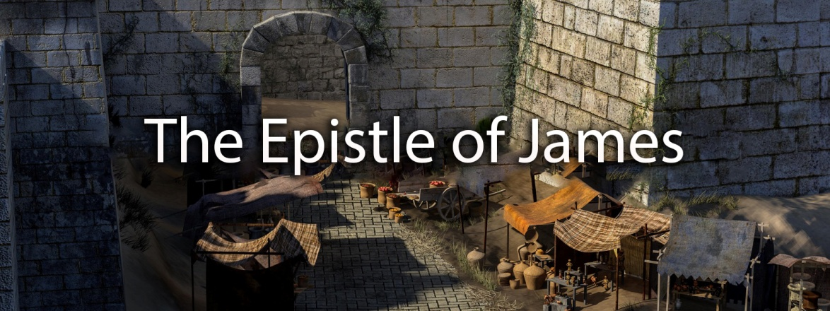

Thirdmill
316 Live Oaks Boulevard
Casselberry, FL 32707 USA

THE EPISTLE OF JAMES
STUDY GUIDE 1.1
Lesson 1: Introduction to James
Section 1: Background

OUTLINE FOR TAKING NOTES
Introduction
I. Background
A. Authorship
1. Traditional Outlook
2. Personal History
B. Original Audience
C. Occasion
1. Location
2. Date
3. Purpose

REVIEW QUESTIONS
1. What reasons do critical scholars give to doubt the traditional outlook on the authorship of James? What response can we give to those reasons?
2. What do we know about the original audience for the Epistle of James?
3. What is the earliest and latest possible date for the Epistle of James? Was the letter likely penned earlier in those dates, or later?
4. What do we know about James, the brother of Jesus, from the Gospels?
5. How did James' role change as we look to the Book of Acts?
6. Where did James spend his life and ministry? What are some events that took place there after the time of Jesus?
7. Was James' audience mostly Jewish, mostly Gentile, or a balanced mixture of both? How does this idea help us interpret the Epistle of James?
8. As you read through the Epistle of James, make a list of the imperatives, or commands, James gives his audience. What can we learn from those commands about how to live well?

QUESTIONS FOR APPLICATION AND REFLECTION
1. Why should it matter to us that James was not a follower of Jesus from the beginning of his ministry?
2. What are some of the things that can cause division in your own church?
3. What does "friendship with the world" look like in the place where you live and work?
4. What is the relationship between wisdom and joy? How does seeking wisdom help to live with joy in difficult times? Have you experienced how this works in your own life? Give an example.

THE EPISTLE OF JAMES
STUDY GUIDE 1.2
Lesson 1: Introduction to James
Section 2: Structure & Content

OUTLINE FOR TAKING NOTES
II. Structure and Content
A. Greeting
B. Wisdom and Joy
C. Wisdom and Obedience
1. Action
2. Favoritism
3. Faith
D. Wisdom and Peace
1. Tongue
2. Two Kinds of Wisdom
3. Inward Conflict
E. Wisdom and the Future
1. Making Plans
2. Hoarding Wealth
3. Waiting Patiently
F. Wisdom and Prayer
G. Concluding Exhortations

REVIEW QUESTIONS
1. How is the structure and tone of James similar to other wisdom literature of James' day?
2. What can we learn about James' character from his short greeting?
3. How does the pursuit of wisdom make "pure joy in the midst of trials" a reality?
4. What are some of the ways we see James' teaching echoing the teaching of Jesus?
5. What are some of the ways James explains the relationship between faith and obedience?
6. What are the specific issues causing disunity among James' original audience?
7. Why would James caution his original audience against making plans and saving up too much money?
8. Why does James place such a significant weight on the tongue (a person's words) as an indicator of their moral standing?
9. What are some good business practices we can see expounded in the Epistle of James?

QUESTIONS FOR APPLICATION AND REFLECTION
1. What are some of the ways you are sometimes tempted to rely on "worldly wisdom" as opposed to "wisdom from God"?
2. How might James' epistle encourage you to wait patiently for the Lord in the midst of trials?
3. As you look around your city/church, what does it look like to "love your neighbor as yourself"?
4. James makes the assertion, "As the body without the spirit is dead, so faith without deeds is dead." Does this elevate right behavior (orthopraxis) or right belief (orthodoxy)? Why/why not?
5. The relationship between faith and works cannot simply be a topic of discussion, but it must impact the way we live our lives as believers. How would you describe this important relationship in your own life?
6. After reading both James 2:14-26 and Galatians 2:16, what can we say about James' and Paul's views on the relationship between faith and justification?
7. Do you think you need to do good works to earn salvation? Or do you believe that we are saved by faith in Christ alone? If you think you need to do good works to merit salvation, how good must you be to be saved?
8. Exactly what did Christ accomplish for you when he died on the cross and rose again? Did he only achieve the possibility of your forgiveness and salvation, or did he really achieve certain forgiveness and salvation?
9. If you died today and faced God, then He asked you, “why should I let you into heaven?”, how would you answer him? Don't you think your answer to this question indicates whether you are trusting in your own merits for your salvation, or trusting only in Christ?

THE EPISTLE OF JAMES
STUDY GUIDE 2.1
Lesson 2: Two Paths of Wisdom
Section 1: Reflective Wisdom

OUTLINE FOR TAKING NOTES
Introduction
I. Reflective Wisdom
A. Need
1. Challenge of Trials
2. Many Kinds of Trials
B. Guidance
1. Testing
2. Perseverance
3. Maturity
4. Reward
C. Faith

REVIEW QUESTIONS
1. Why is "reflective wisdom" important for a healthy understanding of our world?
2. How would this reflective wisdom encourage or correct the wealthy in James' day?
3. What are the various ways we can translate the Greek term "peirasmos"? How do these different translations help us grasp the circumstances facing James' original audience?
4. List here the different kinds of trials James mentioned in the letter bearing his name.
5. What is the twofold New Testament teaching on perseverance? Why are both aspects important to understand?
6. Why is it important to understand the context surrounding James' discussion of the double-minded person?
7. How does knowing Job's situation help us understand James' teaching on reflective wisdom?
8. James 1:17 indicates every good and perfect gift comes from God. Explain the importance of this truth for your own context and ministry.

QUESTIONS FOR APPLICATION AND REFLECTION
1. Have you experienced a particular time of testing in your life? How did the experience change you?
2. How would have reflective wisdom aided you during that time?
3. How would you answer someone who blames God for the difficult situations in their life?

THE EPISTLE OF JAMES
STUDY GUIDE 2.2
Lesson 2: Two Paths of Wisdom
Section 2: Practical Wisdom

OUTLINE FOR TAKING NOTES
II. Practical Wisdom
A. Need
1. Earthly Wisdom
2. Heavenly Wisdom
B. Guidance
1. Standard of God's Law
2. Priorities of God's Law
C. Faith
1. Faith and Works
2. Faith and Justification
Conclusion

REVIEW QUESTIONS
1. How would the people in your context describe the "good life"? How does that differ from James' teaching in 3:13?
2. Take a moment to list out the characteristics for both "earthly wisdom" and "heavenly wisdom" given in James 3:14-18. What are some obvious differences?
3. What do James and Jesus both have to say about "peacemakers"? How do their teachings complement each other?
4. While much of the New Testament cautions us against relying upon the law and our obedience to it for our own salvation, James referred to the law of God in very positive terms. What did he emphasize in regards to the law in his letter?

5. Why would an ancient human king treat any amount of law-breaking as "rebellion"?
6. How does knowing Paul's teaching in Galatians 5:14 help us understand James' encouragement to keep the royal law?
7. Why is a belief in the one true God simply not the same as "saving faith"?
8. Explain the differences between Paul's use of the term "justification" and James' use of the term.

QUESTIONS FOR APPLICATION AND REFLECTION
1. Has your church or ministry ever experienced division? What methods, if any, did you find that brought healing to the situation?
2. James tells us that the law gives freedom. How can God's law provide freedom?
3. Are you ever tempted to minimize the importance of obedience because of Paul's doctrine of justification? Why?
4. After reading through James and watching lesson two in this course, would you say your life is heavily marked by wisdom?
5. Compare James 1:3-4 with Deuteronomy 8:2. How might these passages together speak to the "testing" in your own life?
6. James makes a point to distinguish wisdom from above (heavenly wisdom) and earthly wisdom (wisdom from below). Which of those two do you rely upon most heavily for your decision-making?
7. Are you satisfied with the answer to the apparent contradiction between Paul's teaching on justification by faith and James's teaching on justification by works? Does it help you? Has doubts? Do you have another interpretation?
8. Is there anything in this study on the Epistle of James that has caught your attention? Did you learn anything new? Explain what it means to you personally.

© 2018 by Third Millennium Ministries. All rights reserved. No part of this publication may be reproduced in any form or by any means for profit, except in brief quotations for the purposes of review, comment, or scholarship, without written permission from the publisher, Third Millennium Ministries, Inc., 316 Live Oaks Boulevard, Casselberry, FL 32707 USA.

