Resources For Group Study
Academic
Packet

He Gave Us Scripture
Resources | Study Guides by Section

Thirdmill
316 Live Oaks Boulevard
Casselberry, FL 32707 USA

HE GAVE US SCRIPTURE
STUDY GUIDE 1.1
Lesson 1: Introduction to Biblical Hermeneutics
Section 1: Terminology

OUTLINE FOR TAKING NOTES

Introduction

I. Terminology

A. Biblical Hermeneutics

B. Hermeneutical Process

1. Preparation

2. Investigation

3. Application

REVIEW QUESTIONS

1. What is the linguistic origin of the word "hermeneutics"?

2. Who is considered the father of modern hermeneutics?

3. What is the meaning of biblical hermeneutics?

4. Describe each hermeneutical process:

Preparation
Investigation
Application

QUESTIONS FOR APPLICATION AND REFLECTION

1. What do you hope to learn in this course?

2. How do you normally study Scripture? How do you prepare? What tools do you use?

3. Do you think it is important to learn how to study Scripture more carefully? Why?

4. How do you use your study of Scripture to minister to others?

HE GAVE US SCRIPTURE
STUDY GUIDE 1.2
Lesson 1: Introduction to Biblical Hermeneutics
Section 2: Scientific Hermeneutics

OUTLINE FOR TAKING NOTES

II. Scientific Hermeneutics

A. Biblical Roots

B. Examples

C. Priorities

1. Preparation

2. Investigation

3. Application

REVIEW QUESTIONS

1. What is "scientific hermeneutics"?

2. Explain the example given in the lesson of "scientific hermeneutics" used by Paul in Romans 4:3-5.

3. What was the Hexapla?

4. According to the lesson, what kind of focus did Augustine of Hippo (A.D. 354-430) give to the study of Scripture?

5. According to the lesson, what kind of focus did Thomas Aquinas (A.D. 1225-1274) give to the study of Scripture?

6. Describe the situation of how people interpreted the Bible during the time of Thomas Aquinas, before the Renaissance.

7. What important change occurred during the Renaissance (13th - 16th centuries) with regard to the study of the Bible?

8. When _______ invented the printing press in the 15th century, it made biblical research more available.

9. What was the tendency of the Protestant reformers such as Calvin, Zwingli, and Luther, during the 16th century with regard to biblical interpretation?

10. What was the significance of the term "Sola Scriptura" for the Protestants at the time of the Reformation?

11. At the time of the Enlightenment (17th and 18th centuries), what was the tendency of the majority of biblical scholars with regard to the interpretation of Scripture?

12. What path have the majority of biblical scholars followed with regard to the interpretation of Scripture since the Enlightenment?

13. What path have modern evangelical biblical scholars followed with regard to the interpretation of Scripture?

14. What is the meaning of "exegesis"?

15. Which of the three procedures are typically given least attention in biblical hermeneutics?

QUESTIONS FOR APPLICATION AND REFLECTION

1. Did this lesson convince you of the importance and validity of the "scientific" aspect of hermeneutics? Why, or why not?

2. What are the advantages of using scientific methods of Bible study?

3. What dangers do you think we should avoid as we apply "scientific" methods of Bible study?

4. Do you believe in the principle of "Sola Scriptura"? Why? How does this principle affect the way you study the Bible?

5. Do you believe that the Scriptures are inspired and infallible? Why is this important for you as you study the Bible? How would you defend your view with someone who rejects it?

6. Do you sometimes practice "eisegesis" intead of "exegesis"? Have you observed others doing "eisegesis"? Give examples. How can we avoid doing "eisegesis"?

7. Which procedure of hermeneutics do you need to develop more: preparation, investigation, or application? Explain.

8. Which procedure of hermeneutics do you think is weakest in the preaching and teaching you usually hear: preparation, investigation, or application? Give an example.

HE GAVE US SCRIPTURE
STUDY GUIDE 1.3
Lesson 1: Introduction to Biblical Hermeneutics
Section 3: Devotional Hermeneutics

OUTLINE FOR TAKING NOTES

III. Devotional Hermeneutics

A. Biblical Roots

B. Examples

C. Priorities

1. Preparation

2. Investigation

3. Application

REVIEW QUESTIONS

1. How does the lesson define "devotional hermeneutics"?

2. What is the teaching of Hebrews 4:12?

3. What did Origen (185-254 A.D.) write to Gregory regarding the reading of Scripture?

4. Describe each of the four steps of "Lectio Divina."

lectio
meditatio
oratio
contemplatio

5. What was Calvin's attitude toward devotional hermeneutics?

6. Which theologian wrote the following words? "As I read the words [of 1 Timothy], there came into my soul...a sense of the glory of the Divine Being; a new sense, quite different from any thing I ever experienced before. Never any words of Scripture seemed to me as these words did. I thought within myself, how excellent a Being that was, and how happy I should be, if I might enjoy that God...forever!"

7. James 4:8 says, "Draw near to God and __________."

8. How does the lesson explain that we should prepare for a devotional interpretation the Scriptures?

9. When we ask, "How does this text reveal the author's experience of God?", which step of devotional hermeneutics are we doing?

10. What are the three areas of application when we are doing devotional hermeneutics, according to the lesson?

QUESTIONS FOR APPLICATION AND REFLECTION

1. Would you consider your normal method of Bible study more "scientific" or more "devotional"? Explain.

2. Do you see the need for "devotional" hermeneutics? Why? How can you include that aspect as you study the Scriptures?

3. Have you ever practiced something like Lectio Divina? Would you consider trying it?

4. What practical things can you do to help develop your relationship with God as you study the Bible, and avoid a purely intellectual approach?

5. Which dimension do you think you need to develop more as you apply the Scriptures: concepts, behavior, or emotions?

6. What is the most important teaching you learned in this lesson?

HE GAVE US SCRIPTURE
STUDY GUIDE 2.1
Lesson 2: Preparation for Interpretation
Section 1: Dependence on the Holy Spirit

OUTLINE FOR TAKING NOTES

Introduction

I. Dependence on Holy Spirit

A. Inspiration

1. Divine Source

2. Human Means

B. Illumination

REVIEW QUESTIONS

1. What term is used to refer to the way in which the Holy Spirit moved human beings to write God’s revelation as Scripture and superintended their work in a way that made their writings infallible?

2. 2 Timothy 3:16 says that all Scripture is "________."

3. Define each view of inspiration:

Romantic
Mechanical
Organic

4. Which view of inspiration is defended in the lesson?

5. 2 Peter 3:15 states that Paul wrote his letters with the ______ that God gave him.

6. In Acts 4:25, the apostles say that God spoke by the Holy Spirit through the mouth of his servant ______.

7. The lesson states, "One of the most important implications of the divine origin of Scripture is the Bible's
unquestionable ______."

8. What theologian said, "I have learned to yield this respect and honor only to the canonical books of Scripture: of these alone do I most firmly believe that the authors were completely free from error."

9. What is the difference between the attitude of a "critical interpreter" of Scripture and the attitude of a "submissive" interpreter?

10. What term is used to describe the Holy Spirit’s work of conveying a proper understanding of Scripture to a human being.

11. What was John Owen's view of "illumination"?

QUESTIONS FOR APPLICATION AND REFLECTION

1. How do you prepare yourself before studying the Bible? What could you do to prepare better?

2. Do you sometimes study the Bible as an impersonal exercise, without depending on the illumination of the Holy Spirit? How can you avoid this?

3. Are you a "critical" interpreter of Scripture or a "submissive" interpreter? Explain.

4. What do you think are the most common errors in the way Christians view the inspiration of the Bible? Give examples.

5. Have you changed your view of inspiration as a result of studying this lesson? Explain how.

HE GAVE US SCRIPTURE
STUDY GUIDE 2.2
Lesson 2: Preparation for Interpretation
Section 2: Need for Human Effort

OUTLINE FOR TAKING NOTES

II. Need for Human Effort

A. Importance

B. Influences

1. Exegesis

2. Interaction

3. Experience

Conclusion

REVIEW QUESTIONS

1. 2 Timothy 2:15 says, " Do your best to present yourself to God as one approved, a ______ who does not need to be ashamed and who correctly handles the word of truth."

2. What is "exegesis"?

3. What does the lesson teach about how the Holy Spirit ordinarily illumines us as we study Scripture?

4. What does the lesson teach about whether Scripture is easy to understand?

5. What are the three influences on our interpretation of Scripture that are mentioned in the lesson?

6. What does the lesson teach about how not living in conformity to the Word of God affects our interpretation of Scripture?

7. Mention the examples given in the lesson about how personal experiences may influence our understanding of Scripture.

QUESTIONS FOR APPLICATION AND REFLECTION

1. What kind of effort do you normally put into studying the Scriptures? In what ways do you think you could make a better effort?

2. In what ways do you seek the benefit of other people as you interpret the Scriptures? In what ways could you seek more help from others?

3. Have you ever noticed that when you are not living in conformity with the Word of God, you have a harder time understanding the Bible? Explain your answer.

4. What is the most important thing you have learned from this lesson?

5. Do you think the Bible is sometimes difficult to understand? What sections are especially difficult for you?

HE GAVE US SCRIPTURE
STUDY GUIDE 3.1
Lesson 3: Investigating Scripture
Section 1: Original Meaning

OUTLINE FOR TAKING NOTES

Introduction

I. Original Meaning

REVIEW QUESTIONS

1. According to the lesson, to seek to discover the original meaning of a biblical text means to investigate the "_______, _______, and _______ that the divine and human writers jointly intended the document to communicate to its first audience."

2. According to the lesson, the common tendency is to seek to understand only the ______ that the biblical writer intended to communicate to his original audience.

3. 2 Timothy 3:16 states that all Scripture is useful for "teaching, rebuking, correcting, and training in ________."

4. According to the lesson, what are the three main concerns, or matters to consider, when we seek to discern the original meaning of a biblical text?

QUESTIONS FOR APPLICATION AND REFLECTION

1. Is your tendency to think primarily about the concepts when you try to discover the original meaning of a biblical passage? How can you remind yourself to include the behaviors and emotions?

2. When you participate in a Bible study, what is the typical way they talk about the "meaning" of a Bible passage? Is the emphasis usually almost exclusively on the concepts, or do they include behavior and emotions? What kind of questions could you ask to help the group gain a more complete understanding of the meaning?

3. Read 2 Timothy 3:16. Mention how you could include all the benefits of the Scriptures as you teach or preach from a passage.

HE GAVE US SCRIPTURE
STUDY GUIDE 3.2
Lesson 3: Investigating Scripture
Section 2: Theological Basis

OUTLINE FOR TAKING NOTES

III. Theological Basis

A. Writer

B. Audience

C. Document

1. Organic Inspiration

2. Divine Accommodation

REVIEW QUESTIONS

1. According to the lesson, why is the story of David's sin with Bathsheba only narrated in 2 Samuel, and not in 1 Chronicles?

2. What do we know about Jeremiah that helps us understand his biblical writings?

3. In what book of the New Testament can we find most background information about the apostle Paul?

4. What is "divine accommodation"?

5. What is an "anthropomorphism"?

6. What example is used in the lesson to demonstrate how God sometimes fits His revelation to cultural expectations?

7. What does the lesson teach about the wisdom of using modern translations?

8. What does the lesson teach about the wisdom of learning the original languages of Scripture?

9. What documents have the full authority of God and are without error?

10. What was Jesus' attitude toward the Old Testament, considering the fact that the original documents did not exist in His day?

11. What was the attitude of the early Church toward the New Testament, considering the fact that there were many copies of the New Testament circulating in their time?

12. What does the lesson indicate about how much scholarly research has been devoted to the study and comparison of ancient copies of Scripture?

13. According to the lesson, how much have the copies of the original biblical documents been altered, and how does this affect our ability to recover what the original text said?

QUESTIONS FOR APPLICATION AND REFLECTION

1. When you study a biblical passage, do you normally investigate information about the human author? Do you think it is important? How could you investigate more about that?

2. When you study a biblical passage, do you normally investigate information about the original audience? Do you think it is important? How could you investigate more about that?

3. When you study a biblical passage, do you normally investigate different translations? Do you think it is important? How could you investigate more about that?

4. Which of the three aspects do you think is most important to investigate: the author, the original audience, or different translations? Explain why.

5. Which of the three aspects to you think is usually most neglected by teachers and preachers in their study of a passage: the author, the original audience, or different translations? How does this affect the teaching or preaching on a passage?

6. Does the fact that we do not have the original documents of the Bible cause you to doubt the authority of Scripture or our ability to properly interpret it? Explain your answer.

7. Have you ever studied the original languages of the Bible (Greek and Hebrew)? Would you consider that worthy of doing some day?

HE GAVE US SCRIPTURE
STUDY GUIDE 3.3
Lesson 3: Investigating Scripture
Section 3: Importance

OUTLINE FOR TAKING NOTES

III. Importance

A. Church History

B. Modern Church

Conclusion

REVIEW QUESTIONS

1. Throughout history, what has been the attitude of theologians about pursuing the original meaning of Scripture?

2. What is the name of the early church father who accused the Gnostics of not knowing how to "read Paul," because they did not understand Paul's original meaning?

3. What term did the theologians from the Middle Ages in Europe use to speak of the original meaning of Scripture?

4. Thomas Aquinas said, "Thus in Holy Writ no confusion results, for all the senses are founded on one — the ______ — from which alone can any argument be drawn, and not from those intended in _______."

5. What is the "grammatico-historical method" of Bible interpretation?

6. In general, why did the modern schools of literary criticism begin to disregard the original meaning of Scripture in the early 20th century?

7. What reason did the historians give for disregarding the original meaning of Scripture during the early 20th century?

8 .What reason did the anthropologists give for disregarding the original meaning of Scripture during the early 20th century?

9. What reason did the psychologists give for disregarding the original meaning of Scripture during the early 20th century?

10. What reason did the philosophers give for disregarding the original meaning of Scripture during the early 20th century?

11. By the middle of the twentieth century, many interpreters ignored the ancient writers and audiences and focused entirely on the ______.

12. Who were the "structuralists"?

13. Who were the "reader-response critics"?

14. In the last decades of the twentieth century, literary critics went so far as to say the meaning of the text itself was _______.

15. According to the lesson, how far did some literary critics of the last decades of the twentieth century go with regard to the meaning of a biblical text?

16. In what sense did some literary critics from the last decades of the twentieth century encouraged readers to “deconstruct” ancient texts?

17. According to the Reformers, what was the only way to avoid the hermeneutical tyranny of church authorities in the interpretation of Scripture?

QUESTIONS FOR APPLICATION AND REFLECTION

1. Why is it important to you personally to learn how to carefully investigate the original meaning of a Bible passage?

2. What habits can you develop to do a more careful investigation of the Scriptures?

3. What is the most important thing you learned in this whole lesson?

4. EXERCISE WITH PSALM 42 (Part 1)
In most of the remaining lessons, we will do exercises to practice the principles of hermeneutics explained in the course, studying Psalm 42. There are three major aspects of biblical hermeneutics: preparation, investigation, and application.
Step 1: Preparation
Prepare by asking God to give you wisdom and that He illuminate your heart and mind as you study His Word.
Step 2: Investigation
We recommend that you download and install a free software program called e-Sword.
See the following for PCs: http://www.e-sword.net/downloads.html
There are also versions for MAC.
There is a minimal cost for this program if you purchase it through iTunes.
For iPads, find "e-Sword HD "in the Apps store or go to: http://www.e-sword.net/ipad/
Once installed, you can download different versions of the Bible. To do this, find the "download" menu at the top. Then select the kind of resource ("Bibles" in this case) and browse through the list. Click on "download" for any version you want, and it will be put on the list in the box below. When you are finished selecting the resources, click "download" / "Start" in the same open window, then close the e-Sword program and restart it. The resources should appear.
In addition to the King James version and the KJV+ with Strong's Numbers, which should come with the initial installation, we recommend the following versions, for example:
American Standard
English Standard
Revised Version
Young's Literal Translation
To find Psalm 42, click on Psalms in the list of Bible books in the left margin, then click on "42" in the list of chapters in the column just to the right of the list of the Bible books.
You may also want to copy the information to a new document in your word processor and begin documenting your study of this Psalm.

Read the different versions and write down any important differences you observe.

Write down any question that comes to you as you read the Psalm.

The Author and the Original Audience

Find information about the author (or authors) and the original audience of Psalm 42. You may use e-Sword, a commentary, a study Bible, a Bible dictionary, or an Introduction to the Old Testament. You may look at the list of "Recommended Extra Reading" for this course.

In the case of Psalm 42, there are different opinions about who is the author. You should read different resources before making up your mind.

If you would like to continue using e-Sword, for example, we recommend that you download the following free Bible dictionaries:

Easton's Bible Dictionary
International Standard Bible Encyclopedia
Nave's Topical Bible

For example, to find an article on the "Sons of Korah," or the "Korahites," look in the window with the dictionaries, click on ISBE, and find the name "Korahites" in the column on the right.

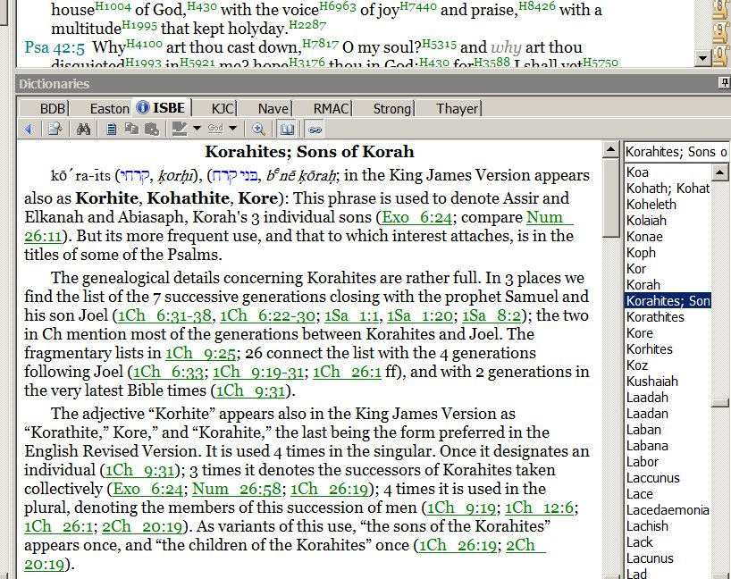

We also recommend that you download the following free commentaries:

Expositor's Bible Commentary
Matthew Henry's Commentary on the Whole Bible
Jamieson, Fausset and Brown Commentary
Keil and Delitzsch Commentary on the Old Testament

To download new resources, find "download" in the menu at the top. Then select the kind of resource and browse through the list. Click on "download" for any resource you want, and it will be put on the list in the box below. When you are finished selecting the resources, click "download" in the smaller open window, then close the e-Sword program and restart it. The resources should appear.
Commentaries will appear in another window on the upper right.

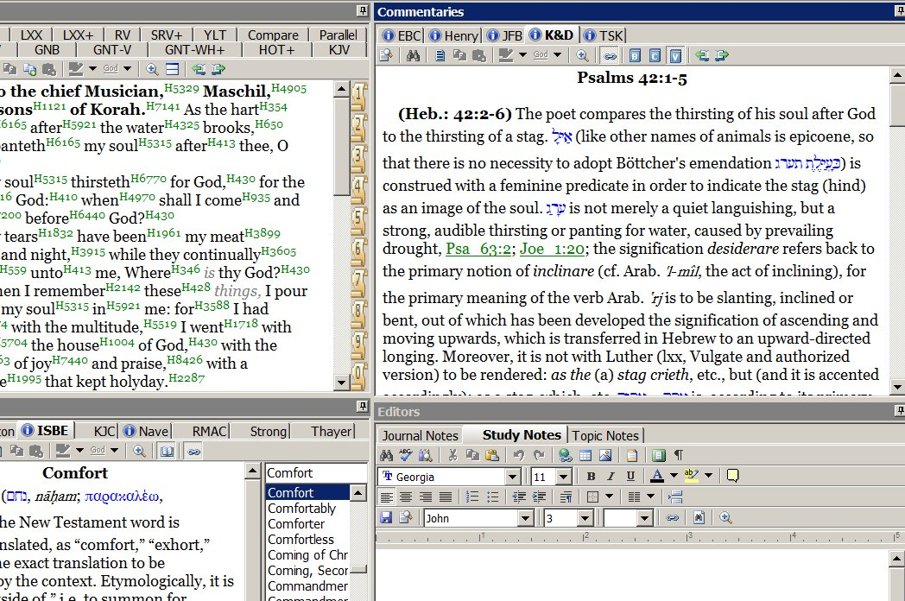

After investigating information about the author and the original audience, write down the information below. (We will continue studying this psalm in future lessons.)

HE GAVE US SCRIPTURE
STUDY GUIDE 4.1
Lesson 4: Approaches to Meaning
Section 1: Objective

OUTLINE FOR TAKING NOTES

Introduction

I. Objective

A. Background

B. Influence

REVIEW QUESTIONS

1. In the terminology used in the lesson, what are "subjects of knowledge"?

2. Describe each approach to knowledge:

Objectivism
Subjectivism
Dialogism

3. "_______ scholars believe that they can interpret the Scripture impartially."

4. What philosopher is considered the "father of modern rationalism"? Why?

5. Who is considered the "father of modern science"? Why?

6. What is "structuralism"?

7. What was the influence of "objectivism" on Critical Biblical Studies?

8. According to the lesson, should reason and scientific methods be used for studying the Scriptures?

9. The lesson states that Bible study is not a science, but an "_____."

10. What point does the lesson make about who can be objective about knowledge?

QUESTIONS FOR APPLICATION AND REFLECTION

1. Do you believe it is humanly possible to arrive at a completely impartial interpretation of a Bible passage? Explain.

2. Are you aware of any ways in which scientific rationalism has influenced the way you study the Bible? Explain.

3. Have you ever encountered critical biblical views of the Scriptures that reject its infallible authority? How did it affect you? How did you deal with it? Do you think this lesson has prepared you to deal with something like this better if you encounter it again in the future?

4. Mention an example of how someone distorted the correct interpretation of a Bible passage. What was the error?

HE GAVE US SCRIPTURE
STUDY GUIDE 4.2
Lesson 4: Approaches to Meaning
Section 2: Subjective

OUTLINE FOR TAKING NOTES

II. Subjective

A. Background

B. Influence

REVIEW QUESTIONS

1. "Subjectivists recognize that human beings, the world, and matters of faith, are too ______ to be discerned by scientific rationalism."

2. What is the name of the Scottish skeptic philosopher who believed that our emotions, desires and mental categories always influence our thinking?

3. Explain what Immanuel Kant proposes regarding knowledge.

4. What was the view of 19th century Romanticism regarding knowledge?

5. What was the view of late 20th century Post-Structuralism regarding knowledge?

6. Into what category does the lesson put the French theorists Jean Francois Lyotard, Jacques Derrida, and Michel Foucault?

7. What was the influence of "subjectivism" on Critical Biblical Studies?

8. What does the lesson teach about whether subjectivism can be harmful in the study of the Scriptures?

QUESTIONS FOR APPLICATION AND REFLECTION

1. Do you believe that the Bible is too complex to be understood rationally, that it is impossible to find any objective meaning in a Bible passage? Explain.

2. Are you aware of any ways in which subjectivism has influenced the way you study the Bible? Explain.

3. Have you ever encountered subjectivist views of the Scriptures that made you question the possibility of finding objective meaning? How did it affect you? How did you deal with it? How do you think you could deal with something like this better if you encounter it again in the future?

HE GAVE US SCRIPTURE
STUDY GUIDE 4.3
Lesson 4: Approaches to Meaning
Section 3: Dialogical

OUTLINE FOR TAKING NOTES

III. Dialogical

A. Background

B. Influence

C. Comparison

1. Authority-Dialog and Objective

2. Authority-Dialog and Subjective

Conclusion

REVIEW QUESTIONS

1. What is the "dialogical" approach to interpreting Scripture?

2. According to the lesson, does a Bible text has objective meaning?

3. What theologian is known for proposing the model of interpretation of Scripture called the "hermeneutical circle"?

4. What is meant by the "hermeneutical spiral"?

5. Thomas Kuhn argued that scientific knowledge results from interactions between objective reality and our _____________.

6. What does Hans-Georg Gadamer mean when he speaks of a "horizon"?

7. What does Hans-Goerg Gadamer mean when he speaks of interpreting meaning in terms of the "fusion of two horizons"?

8. What is the particular way that Evangelicals practice the "dialog" method of interpretation of Scripture?

9. Which approach does to interpreting Scripture does the lesson prefer?

10. What do objectivism and subjectivism have in common with regard to interpreting Scripture?

11. What does the lesson mean by "authority-dialog"?

12. What do "objectivism" and the "authority-dialog" method have in common?

13. What do "subjectivism" and the "authority-dialog" method have in common?

QUESTIONS FOR APPLICATION AND REFLECTION

1. What is the most significant thing you learned in this whole lesson?

EXERCISE WITH PSALM 42 (Part 2)

The Authority-Dialog Method

Try the "authority-dialog” method briefly with Psalm 42:1. a) Write down your initial thoughts about the verse. b) Next, think about the author. What circumstances might have led him to write this? Write your thoughts. c) Reflect on what the verse might have meant to the original audience, and write down more thoughts. d) Think about people around you. What are their needs? Write down more thoughts about the meaning of the verse. e) Finally, reflect on your own situation and write down more thoughts about the meaning of this verse. Now note how you modified your understanding of the verse as you "dialogued" with it.

HE GAVE US SCRIPTURE
STUDY GUIDE 5.1
Lesson 5: The Complexity of Meaning
Section 1: Literal Sense

OUTLINE FOR TAKING NOTES

Introduction

I. Literal Sense

A. Multiple Meanings

B. Singular Meaning

REVIEW QUESTIONS

1. According to the lesson, does a biblical passage have more than one meaning?

2. How does the lesson understand the "literal sense" (sensus literalis) of a biblical passage?

3. What is the "allegorical approach" to interpreting Scripture?

4. The origin of the "allegorical approach" to interpreting Scripture is often traced to ________.

5. Philo of Alexandria viewed the Hebrew Scriptures as allegories that revealed _____________.

6. Early Christians were influenced by the allegorical method of interpretation especially through what school?

7. One of the most famous early Christian teachers who was heavily influenced by the allegorical method of interpretation of Scripture, and who lived from 185 to 254 A.D., was ________.

8. Origen divided the meaning of Scripture into two categories: the literal sense and the _______ sense.

9. What school of Greek philosophy had a heavy influence on early Christian methods of interpreting Scripture, leading them toward the allegorical approach?

10. According to the lesson, what concept from some Greek philosophers influenced early Christian methods of biblical interpretation?

11. What was a "Quadriga" in the early roman society?

12. How was the term "Quadriga" used with regard to biblical interpretation?

13. According to Bernard of Clairvaux, when the Song of Solomon speaks of the "beams" and the "rafters" of a house (1:17), these are both symbols referring to ______ and ______ respectively.

14. What did Martin Luther and John Calvin think about the allegorical method of interpreting Scripture?

15. What did Thomas Aquinas teach about the relationship between the literal meaning of Scripture and the spiritual meanings?

16. During the medieval period, what did the church authorities assert about their ability to gain insights into spiritual meanings of Scripture that had no connection to the literal meaning?

17. What change in scholarly study during the Renaissance caused a dramatic shift in the interpretation of Scripture?

18. During the Renaissance, Protestants argued that Scripture's literal sense, or original meaning, is both singular and ______.

19. What illustration best expresses the Protestant view of the meaning of Scripture during the Renaissance?

QUESTIONS FOR APPLICATION AND REFLECTION

1. Do you agree that there is one meaning to a Bible passage, but that there are many partial summaries of that one meaning? Why or why not?

2. How would you use the illustration of a gem with multiple facets to interpret Philippians 4:13, “I can do all things through him who strengthens me”? What is the one meaning and what are the various smaller aspects of that meaning?

3. How would you explain the difference between the “literal meaning” and the “literal interpretation” of Philippians 4:13 (“I can do all things through him who strengthens me”)? Take into account the context of the verse.

4. Give an example of an invalid allegorical method of interpreting a Bible passage that you have heard or read.

HE GAVE US SCRIPTURE
STUDY GUIDE 5.2
Lesson 5: The Complexity of Meaning
Section 2: Full Value

OUTLINE FOR TAKING NOTES

II. Full Value

A. Original Meaning

B. Biblical Elaborations

C. Legitimate Applications

Conclusion

REVIEW QUESTIONS

1. What does the lesson mean when it speaks of the "full value" of a biblical passage?

2. How does the lesson define the "original meaning" of a passage?

3. What does the lesson mean by "biblical elaborations" on a passage of Scripture?

4. What are the three kinds of "biblical elaborations" mentioned in the lesson?

5. Numbers 35:20-25 says that if a person accidently kills someone, he should not be put to death but protected from avengers. What kind of biblical elaboration is this, according to the lesson?

6. Jesus comments on the commandment forbidding murder in Matthew 5:21-22, saying that if you are angry, you are liable to judgment. What kind of biblical elaboration is this, according to the lesson?

7. According to the lesson, are applications of Bible passages inspired?

8. According to the lesson, are the original meaning and biblical elaborations inspired?

9. When the Heidelberg Catechism answers the question, "What is God's will for you in the sixth commandment?" and answers by saying, "I am not to belittle, insult, hate, or kill my neighbor, not by my thoughts, my words, my look or gesture, and certainly not by actual deeds,..." what should this be called, according to the terminology of the lesson?

10. When we make judgments in our modern world regarding abortion, euthanasia, suicide, war, and abject poverty, what are we doing, according to the terminology of the lesson?

11. The lesson concludes that there is "one _____ original meaning for every biblical passage."

12. The lesson concludes that the original meaning of a biblical passage "touches the concepts, behaviors and _____ of the original audience in many different ways."

13. The lesson concludes that, besides the original meaning of a biblical passage, in order to discover its "full value," we also have to "find guidance in ____________ and we also have to make many legitimate ________ to our world today."

QUESTIONS FOR APPLICATION AND REFLECTION

1. Can you think of any aspects of the "original meaning" of the commandment "You shall not steal" (Exodus 20:15)? What concepts, behaviors, or emotions are included?

2. Can you think of any "biblical elaborations" of the commandment "You shall not steal" (Exodus 20:15)?

3. Can you think of any "legitimate applications" for today of the commandment "You shall not steal" (Exodus 20:15)?

4. Consider Leviticus 19:26-28. Try to discover the original meaning of these verses. How would you apply the teaching of these verses in your own context today?

5. Read Hebrews 4:12. Have you ever discovered new dimensions of the meaning of a Bible passage years after studying it? Give an example.

6. Hebrews 4:12. Can you give an example of how the Holy Spirit has spoken to you in a special way through a passage in the Bible that seems to "cut" and "penetrate" your heart?

HE GAVE US SCRIPTURE
STUDY GUIDE 6.1
Lesson 6: Discovering Meaning
Section 1: Guides

OUTLINE FOR TAKING NOTES

Introduction

I. Guides

A. Writer

B. Document

C. Audience

D. Interdependence

REVIEW QUESTIONS

1. The "grammatico-historical" method of interpretation seeks to discover the meaning of Scripture in terms of grammar, what's written on its pages, and in terms of its ancient ___________.

2. The "grammatico-historical" approach to biblical interpretation can be traced throughout church history, but especially from the time of ________.

3. What are the three main "guides" mentioned in the lesson that help us interpret Scripture using the grammatico-historical method?

4. Does the lesson teach that people with little education cannot understand the meaning of a Bible text?

5. Does the lesson teach that, even if the author of a Bible book is not specifically identified, we can still create a profile of the author?

6. How does knowing about the apostle John, the author of the gospel, help us understand a text such as John 3:16? What is the example given in the lesson?

7. What is the smallest unit of meaning mentioned in the lesson?

8. What is a "morpheme"?

9. What is the largest unit of meaning mentioned in the lesson, in the context of Bible interpretation?

10. According to the lesson, what does the word "so" (houtos) mean in John 3:16?

11. According to the lesson, at the time the Bible was composed, did many people know how to read?

12. According to the lesson, what audience was John especially writing to in his gospel?

13. What advice does the lesson give about the emphasis we should give to the different guides to the meaning of Scripture?

14. Describe each "fallacy" of interpretation:

intentional fallacy
graphic fallacy
affective fallacy

QUESTIONS FOR APPLICATION AND REFLECTION

1. Do you think the "grammatico-historical" method is the best way to interpret the Scriptures? Do you use it? How could you practice it better?

2. Investigate briefly the writer of Exodus 20:4-5 (no graven image). Write down important details. Note why this is important.

3. Investigate briefly the document of Exodus 20:4-5. Write down important details about the words, grammar, figures of speech, sentence structure, and literary context.

4. Investigate briefly the audience of Exodus 20:4-5. Write down important details. Note why this is important.

HE GAVE US SCRIPTURE
STUDY GUIDE 6.2
Lesson 6: Discovering Meaning
Section 2: Summaries

OUTLINE FOR TAKING NOTES

II. Summaries

A. Complexity of Passage

B. Uniqueness of Interpreter

C. Needs of Audience

Conclusion

REVIEW QUESTIONS

1. How does the lesson define a "summary," in the context of biblical interpretation?

2. How does a "summary" help us study a passage?

3. What illustration does the lesson give to explain how there can be different legitimate perspectives of the same biblical passage?

4. What are the three factors that show the need for multiple "summaries" of a biblical passage?

5. "The complexity of Scriptural passages is largely due to the fact that their original meaning is _________."

6. According to the lesson, can we summarize the meaning of a passage in many different ways and still be true to its literal sense?

7. According to the lesson, when several biblical passages comment on another passage, such as Psalm 110:1, do they always focus on the same aspect?

8. How does the lesson interpret the fact that in Matthew 2, it says when Jesus went to Egypt and returned, that this fulfilled the passage in Hosea, "Out of Egypt I have called my son"?

9. What are the three ways that New Testament writers use Old Testament literature, according to the lesson?

10. According to the lesson, are all summaries of a biblical passage are equally valuable and legitimate?

11. "All interpreters come to biblical writings with different sets of concerns, assumptions, backgrounds and ________."

12. "In order to apply the Bible in responsible and relevant ways, we have to find summaries that are helpful to our specific _______."

QUESTIONS FOR APPLICATION AND REFLECTION

1. Write down several different "summaries" of Exodus 20:4-5. That is, describe the meaning of the passage from several different perspectives.

2. Write down different applications of Exodus 20:4-5, thinking of different groups of people. For example, what application would you recommend for a Sunday School class with young children? For a group adults in a home Bible study? For a youth group of high school students?

4. EXERCISE WITH PSALM 42 (Part 3)

The Third Aspect to Investigate: The Text
We have already investigated the author and the original audience of Psalm 42. Now we will continue the investigation of the original meaning, looking at the third aspect to be investigated: the text. This includes four areas: the semantics, the morphology, the syntax, and the literary context. First, we will look at semantics.

Semantics
This is the study of the meaning of the words. Here you should study words that you may not understand, or words that have important theological significance. It is especially important to see how the same author uses the word in similar passages.

To study key words, you can use the following resources:

Dictionaries. You should learn to use especially a Hebrew dictionary (for Old Testament) and a Greek dictionary (for New Testament).

Concordances. A concordance lists all the uses of a particular word throughout the Bible.

e-Sword [http://www.e-sword.net/] provides these resources.
Let's look at an example. You might use e-Sword to look up the word "hope" used in Psalm 42:5. Use the King James Version w/ Strong's Numbers (KJV+) of the Bible (which comes with the initial installation), look up the verse (see the book and chapter lists in the left margin), click on the green number beside the word, and see the definition and pronunciation of the Hebrew word "yachal."

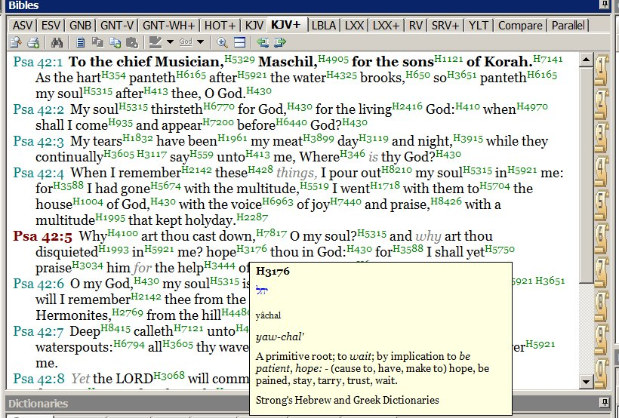

For more precise definitions, you can also install the Hebrew dictionary, Brown Driver Brigg's Hebrew Definitions (BDB). Then when you click on the number after the word, a more complete list of meanings appears in the box below.

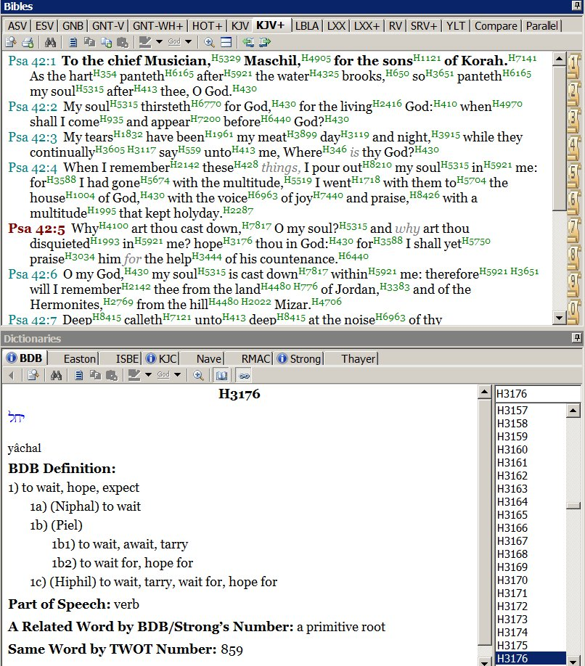

What are some of the definitions of the Hebrew word "yachal"?

For words like "Hermon," or "Mizpar," you may want to use the Bible dictionaries that you hopefully installed previously, such as the International Standard Bible Encyclopedia or Easton's Bible Dictionary.

Finally, if you wish to do your own word study of a word like "deep," finding other places where the same word is used in the Bible, you can download the King James Concordance (KJC) and look at all the passages.

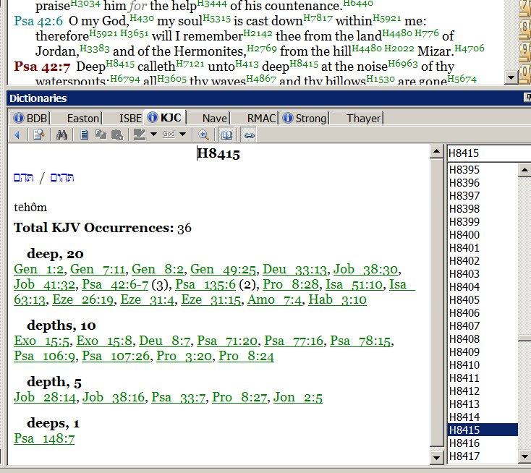

What other words do you think it would be good to study in Psalm 42? Write the definitions.

HE GAVE US SCRIPTURE
STUDY GUIDE 7.1
Lesson 7: Applying Scripture
Section 1: Necessity

OUTLINE FOR TAKING NOTES

Introduction

I. Necessity

REVIEW QUESTIONS

1. How does the lesson define an "application"?

2. How does the lesson define "original meaning"?

3. Proper application should be faithful to the original meaning, but also take into account _________ times, cultures and individuals.

4. What is the main point of James 1:21-25?

5. 1 Corinthians 10:11 says that the stories of Israel in the desert were written down as ______ for us.

6. Application must take into account both the _______ with the ancient context and the __________ that have occurred since then.

7. What phrase is often used in the New Testament to distinguish the Old Testament times from the New Testament period?

QUESTIONS FOR APPLICATION AND REFLECTION

1. When you teach or preach on a Bible passage, do you think it is necessary to help people make appropriate applications? Some people say that when we teach or preach on a Bible passage, our only responsibility is to explain the passage, and that the Holy Spirit will help each person apply the passage to their own lives. What do you think of that statement?

2. Some people think that, since each person is different, we cannot make appropriate applications when we teach or preach on a Bible passage. What do you think of that statement?

HE GAVE US SCRIPTURE
STUDY GUIDE 7.2
Lesson 7: Applying Scripture
Section 2: Connections

OUTLINE FOR TAKING NOTES

II. Connections

A. God

1. Eternal Counsel

2. Character

3. Covenant Promises

B. World

C. People

1. Sinful Images

2. Religious Divisions

3. Classes

REVIEW QUESTIONS

1. What three areas are highlighted in the lesson to show the "connections" between the ancient audience of a biblical passage and the modern audience?

2. What does it mean when we say God is "immutable"?

3. "It's been said that God is _______ immutable, but _______ mutable."

4. "I think of that descriptor of God as the ________ in a _______ universe."

5. What is God's "eternal counsel"?

6. Ephesians 1:11 states that God works out _______ in conformity with the purpose of His will.

7. The lesson teaches that God's character, that is, "His essence, persons, and _______ never change."

8. James 1:7 calls God "The Father of the heavenly lights, who does not ______ like shifting shadows."

9. According to the lesson, how do we discern when God's words can be considered a promise?

10. The lesson says that when God hasn't made a promise, His words are best understood as _____________.

11. What does the lesson teach about whether the laws of nature change?

12. What are the three areas of similarity between modern people and the people that first received the Scriptures, according to the lesson?

13. Does the lesson teach that the Ten Commandments no longer apply to God's people since the time of Christ?

14. What characteristics of man are mentioned in the lesson as aspects of the image of God?

QUESTIONS FOR APPLICATION AND REFLECTION

1. Has this lesson changed the way you understand God's "immutability"? In what way?

2. How has this lesson given you greater confidence in being able to understand the original meaning of a Bible passage?

3. What practical things can you do to "connect" better with the original audience and the world they lived in, when you study a Bible passage?

4. What "connections" can you make with the original audience as you study Psalm 42?

HE GAVE US SCRIPTURE
STUDY GUIDE 7.3
Lesson 7: Applying Scripture
Section 3: Developments

OUTLINE FOR TAKING NOTES

III. Developments

A. Epochal

B. Cultural

C. Personal

Conclusion

REVIEW QUESTIONS

1. The Bible's sees world history in three main stages. What are these stages?

2. What illustration is used to describe the way biblical history develops?

3. What examples of cultural differences between biblical times and modern times are mentioned in the lesson?

4. "The progressive nature of God's rule over creation has resulted in periodic developments that create _______ between epochs."

5. How have the norms for making sacrifices changed throughout Bible history?

6. What cultural detail from the Book of Revelation may help us interpret the book? How does it help us?

QUESTIONS FOR APPLICATION AND REFLECTION

1. What is the most important thing you learned in this whole lesson?

2. EXERCISE WITH PSALM 42 (Part 4)

We will continue the study of the text of Psalm 42. We already looked at the semantics, and now we will look at the morphology, the syntax, and the literary context.

Morphology (the form of the words)

Sometimes it may be important to verify the form of a word, especially verbs. Without knowing Hebrew, it is a bit difficult to study the morphology. Furthermore, there are fewer tools for this in programs like e-Sword. (In Greek, there are more resources.) Nevertheless, let's look at one example in Psalm 42, verse 5. Look at the phrase, "Hope in God, for I shall again praise Him."

What is the morphology of the word "hope"? First, is this a noun or a verb in this sentence?
We can return to the "Brown-Drivers Brigg's Hebrew Definitions" to get some help.

Find where it gives the "Part of Speech" of the word.

Is it a verb or a noun?

Now that we know "hope" is a verb in Psalm 42:5, let's continue with the morphological study. What is the mood of the verb? Software such as e-Sword at the present do not offer resources that analyze such aspects of Hebrew morphology (only resources to analyze Greek morphology).

Nevertheless, let's assume that the majority of the versions have translated it properly, "Hope in God,..." What is the mood?

The indicative mood makes a statement.
The infinitive mood is the basic form of a verb, expressing no time, often used with "to...".
The subjunctive expresses doubt or something contrary to fact.
The imperative mood expresses a command.

Which mood do you think it is when it says "Hope in God,..."?

Other resources, such as Logos software, indicate that "hope" in Psalm 42:5 is a verb in the imperative mood. So it seems the psalmist is talking to himself here, encouraging himself to hope in God, to wait on God.

Why are you cast down, O my soul, and why are you in turmoil within me?
Hope in God; for I shall again praise him, my salvation.

What does the mood of the verb "hope" suggest to you about dealing with discouragement when something is going wrong?

Syntax (the structure)
Look at verse 1 of Psalm 42: "As the deer pants for flowing streams, so pants my soul for you, O God."
This sentence has two main parts, two clauses.

How would you describe the relationship between the two?

More Syntax
The key to Hebrew poetry is not rhyme, but parallelism. Note in Psalm 42 how many phrases repeat similar thoughts with different words. Notice also how verses 5 and 11 are exactly the same.

What does the fact that verses 5 and 11 repeat the same thought suggest to you?

Literary Context
Some scholars believe that Psalms 42 and 43 were originally one single psalm. But not everyone agrees. You can study the issue and draw your own conclusion.

As you study Psalm 42, it is important to consider the context of the whole book of Psalms. What is their purpose? How were they used? In what historical context were they written? What kinds of Psalms are there?

Look at verse 4:

These things I remember, as I pour out my soul: how I would go with the throng and lead them in procession to the house of God with glad shouts and songs of praise, a multitude keeping festival.

What do you think the psalmist is remembering here?

What did the temple represent for the people of God during the time of the Old Testament?

HE GAVE US SCRIPTURE
STUDY GUIDE 8.1
Lesson 8: Modern Application and Old Testament Epochs
Section 1: Epochal Divisions

OUTLINE FOR TAKING NOTES

Introduction

I. Epochal Divisions

A. Variety

B. Outline

C. Implications

REVIEW QUESTIONS

1. The lesson states that, "when it comes to applying the Old Testament in our day, we should never _________ the past, but we should also never _________ the past."

2. According to the lesson, when did theological changes occur in the history of the Old Testament?

3. "And when the (theological) changes were significant enough, they became the basis for identifying __________."

4. What illustration from nature is used in the lesson to explain how theological changes occur throughout the Old Testament?

5. What is the popular way of dividing Bible history into epochs recommended in the lesson?

6. What is the Hebrew word (the transliteration) for "covenant"?

7. Name the major covenants of the Bible in their proper chronological order.

8. Describe the emphasis of each major covenant.

9. What does the fact that there are different divisions of the Old Testament show us about how God wanted his people to apply theological themes?

10. Hebrews 8:13 says, "By calling this covenant 'new,' he has made the first one ______."

11. "The Old Testament is not ________; rather we live in a new epoch."

12. According to the lesson, how do we wage war now under the new covenant?

QUESTIONS FOR APPLICATION AND REFLECTION

1. In the Old Testament, God told His people to destroy the enemies in the Promised Land. See for example Joshua 6:17. How would you apply passages like this to your own life today?

2. How do the epochal changes in the Old Testament affect the way you apply passages that indicate punishments for certain sins, like the death penalty for murder (Exodus 21:12), or the death penalty for cursing your parents (Exodus 21:17)?

HE GAVE US SCRIPTURE
STUDY GUIDE 8.2
Lesson 8: Modern Application and Old Testament Epochs
Section 2: Epochal Developments

OUTLINE FOR TAKING NOTES

II. Epochal Developments

A. Characters

B. Storyline

C. Authors

1. About the Past

2. For the Present

D. Connections

1. Backgrounds

2. Models

3. Anticipations

Conclusion

REVIEW QUESTIONS

1. If we learn about the underlying theological structures of the Old Testament epochs, we discover that "these theological changes actually reflect the ______ development of a single growing faith."

2. Who are the two main characters throughout biblical history?

3. God wanted to extend His kingdom to the earth, so that the earth would become like ______.

4. According to the lesson, what is the main purpose of God in the drama of Scripture?

5. Describe the unique drama that each period of biblical covenants, or each "chapter", contributes to the main story of the Bible.

6. Old Testament authors wrote _____ the past, but ____ the present.

7. What was the purpose of Moses in writing Genesis?

8. Biblical authors often used earlier events as ______ for their audience, in order to explain something to them in their own time.

9. Old Testament authors presented models for their audiences to imitate or _______.

10. Explain whether the battle of Jericho and the battle of Ai were examples to imitate or reject.

11. "In modern application our task is to extend the ______ built by biblical writers for their original audience to our modern lives."

QUESTIONS FOR APPLICATION AND REFLECTION

1. What practical lessons can we learn from the stories of Jericho (Joshua 2-6) and Ai (Joshua 7) to apply to our lives today?

2. What is the most significant thing you learned in this whole lesson?

3. EXERCISE WITH PSALM 42 (Part 5)

Original Meaning

We will now finalize the second main step of biblical interpretation, the step of investigation. We have studied the author, the original audience, and the text. Now we will draw some conclusions about the "original meaning" of Psalm 42.

To conclude this step, first write down what you consider the main theme of Psalm 42. What makes it special?

Now write down what you think God meant to say to the original audience when He inspired the author to write it. What changes did He want to produce in the original audience? Remember the three areas of change: concepts, behavior, and emotions.

HE GAVE US SCRIPTURE
STUDY GUIDE 9.1
Lesson 9: Modern Application and the New Covenant
Section 1: Fulfillment

OUTLINE FOR TAKING NOTES

Introduction

I. Fulfillment

A. Old Testament

B. Intertestamental Period

C. New Testament

REVIEW QUESTIONS

1. What is the "pivotal event" that changes the way we understand and apply Scripture today?

2. Jeremiah 31:31-34 says, "'The days are coming,' declares the Lord, 'when I will make _______ with the people of Israel and with the people of Judah... I will put my law in their minds and write it on their hearts. ...I will forgive their wickedness and remember their sins no more.'"

3. For the people in the time of Jeremiah, the new covenant mentioned in Jeremiah 30-31 was associated with what important future event?

4. What phrase describes the time of Israel's restoration, according to the Old Testament perspective?

5. According to Jeremiah 29:10-14, how long would Israel have to experience the captivity in Babylon before seeing the fulfillment of the promises of restoration?

6. Were all of the promises of Jeremiah regarding the new covenant fulfilled when Israel returned from captivity to Jerusalem?

7. Why were some of the promises of Jeremiah regarding the blessings and restoration of Israel postponed? How long were they postponed?

8. What phrase did the rabbis of the period between the Old and New Testaments use to refer to the period that included both Israel's prior history and their current circumstances?

9. What phrases did the rabbis of the period between the Old and New Testaments use to refer to the time when God's purposes for history would be fulfilled?

10. In what sense did the new covenant age begin when Christ came?

11. Describe each stage of "inaugurated eschatology".

Inauguration
Continuation
Consummation

QUESTIONS FOR APPLICATION AND REFLECTION

1. Can you think of some aspects of your salvation that were already accomplished in the stage of inauguration? What aspects of your salvation are in process now? What aspects of your salvation will not be accomplished until the time of the consummation?

2. Why is it important to make these distinctions? Can you think of examples of confusion because of a failure to make these distinctions?

HE GAVE US SCRIPTURE
STUDY GUIDE 9.2
Lesson 9: Modern Application and the New Covenant
Section 2: Application

OUTLINE FOR TAKING NOTES

II. Application

A. Guidelines

1. Old Testament

2. New Testament

B. Example

Conclusion

REVIEW QUESTIONS

1. The Old Testament describes six major covenants, but the books themselves were written during only two of those covenant epochs. Which periods were they?

2. Is the phrase "kingdom of God" used frequently in the Old Testament?

3. Jesus frequently talked about how the ________ is at hand.

4. According to the lesson, in what ways was Jesus a "second Moses"?

5. Did the New Testament writers show how Jesus fulfilled Old Testament teachings in all three stages of the new covenant? Explain.

6. The entire New Testament was written during the _______ stage of the new covenant.

7. What is the difference between the way people at the time of the New Testament looked for guidance, and the way we look for guidance today?

8. Explain the teaching of the lesson regarding the difference between miracles at the time of the New Testament and miracles today.

9. What doctrinal issue was given great attention in the New Testament because it was particularly important for the inauguration of the new covenant?

10. How does the theme of warfare apply to the different stages of the fulfillment of the new covenant?

Inauguration
Continuation
Consummation

11. Ephesians 6:1 says, "For our struggle is not against flesh and blood, but against the rulers, against the authorities, against the powers of this dark world and against the ____________."

QUESTIONS FOR APPLICATION AND REFLECTION

1. Did you learn anything in this lesson about guidance that was helpful? Explain.

2. Did you learn anything in this lesson about miracles that was helpful? Explain.

3. Who would be to you what the Gentiles were to the Jews at the time of Christ? How would you apply the biblical principle of breaking down the barrier between Jews and Gentiles to make one unified people to your own life and your own church today?

4. What is the most important thing you learned in this whole lesson?

5. EXERCISE WITH PSALM 42 (Part 6)

Contemporary Application
Now we move on to the third and final main step of biblical interpretation, contemporary application.

Read Psalm 42 again. Consider the following two things:

a) First, consider what "connections" (similarities) you see between the experience of the author or original audience of the psalm and what you sometimes experience.

You may never have been in a situation exactly like the author of Psalm 42, but maybe you have been unable to attend worship as often as you would like, or unable to attend a church where the worship was meaningful to you. Furthermore, think about Christians in some other countries where public worship is not legal. How about the fact that people were making fun of the author? How about the fact that he was probably being persecuted in some way?

What "connections" can you make with the author of Psalm 42 and his audience?

b) Secondly, what "developments" have occurred between the time period of the original audience and your contemporary context that are important to remember as you study this psalm?

For this process, we need to consider any "biblical elaborations" on the text, any other passages that comment on it, we need to consider any "epochal changes," and we need to consider "cultural changes."

We will give some suggestions for Psalm 42:

Notice verse 4:

These things I remember, as I pour out my soul: how I would go with the throng and lead them in procession to the house of God with glad shouts and songs of praise, a multitude keeping festival.

Where did they need to go to experience the special presence of God at the time this psalm was written? To the temple, right?

Now consider this:

What has changed since then in the way we can experience the special presence of God? Think of what happened in the temple when Jesus died.

And Jesus cried out again with a loud voice and yielded up his spirit. And behold, the curtain of the temple was torn in two, from top to bottom.... (Matthew 27:50-51).

Hebrews 20:19-22 explains the privilege we have now:

Therefore, brothers, since we have confidence to enter the holy places by the blood of Jesus, by the new and living way that he opened for us through the curtain, that is, through his flesh, and since we have a great priest over the house of God, let us draw near with a true heart in full assurance of faith, with our hearts sprinkled clean from an evil conscience and our bodies washed with pure water.

What has changed?

Notice also verse 9 of Psalm 42:

I say to God, my rock: "Why have you forgotten me?"

When he says, "Why have you forgotten me?", does this remind you of something Jesus said on the cross?

My God, my God, why have you forsaken me? Matthew 27:46

What did Christ do to make it possible for us to be in God's presence?

HE GAVE US SCRIPTURE
STUDY GUIDE 10.1
Lesson 10: Biblical Culture and Modern Application
Section 1: Foundations

OUTLINE FOR TAKING NOTES

Introduction

I. Foundations

A. Importance

B. Opposing Ideals

C. Variety

REVIEW QUESTIONS

1. How does the lesson define "culture"?

2. What is the "cultural mandate"?

3. If we consider the creation to be like a temple, instead of a statue, what did God place there to represent Him?

4. "One scholar has called redemption '________'".

5. In the ancient world, what did it mean when they called the kings of nations "images of god"?

6. "Every cultural development in accordance with God's will is a sacred ______ service to God."

7. The Hebrew words "avad" and "shamar" used in Genesis 2:15, when Adam and Eve are told to "work" the garden and "take care of it," are only used together by Moses in one other passage. How are the words used in that passage?

8. According to the lesson, is culture morally neutral?

9. What are the two categories that all cultures fall into?

10. What is "common grace"?

11. Are there similarities between those who follow God and those that oppose Him? If so, why?

12. From the beginning of creation, has God approved or disapproved cultural variety?

QUESTIONS FOR APPLICATION AND REFLECTION

1. In what ways are you fulfilling the "cultural mandate"? What other things could you do to fulfill it better?

2. How do you think we should relate to culture in general? Should we separate ourselves from it? Should we try to go along with the current? Should we try to transform it for good?

3. In what ways do you see common grace in the life of non Christians around you? How does it affect your attitude toward them to know they have God's grace in their lives?

4. How does it change your life to know that God approves of cultural variety? Do you tend to avoid people and cultures that are not like you?

HE GAVE US SCRIPTURE
STUDY GUIDE 10.2
Lesson 10: Biblical Culture and Modern Application
Section 2: Developments

OUTLINE FOR TAKING NOTES

II. Developments

A. Importance

B. Opposing Ideals

C. Variety

REVIEW QUESTIONS

1. While the Pentateuch was written during the epoch of Moses, all the rest of the Old Testament was written during the epoch of the royal covenant with ______.

2. During the epoch of the new covenant, instead of focusing on the national culture of Israel as in the Old Testament, the focus is on ______.

3. What is the difference between the way the rabbis of the period between the Old and New Testaments thought of the coming age of the rule of the Messiah, and the way Jesus and His apostles explained it?

4. What do we learn from Revelation 11:15 about the consummation of God's kingdom rule?

5. During the Old Testament times, in service to whom did the Gentile nations develop their cultures?

6. In spite of their fundamental differences, the Gentile cultures and the Israelite cultures had similarities because of sin among God's people and because of _______ shown to the Gentiles.

7. What change occurred in the New Testament regarding the role of the Gentiles?

8. Was the dividing line between the Church and the world absolute in the time of the New Testament?

9. Did the Levitical priests, kings, and families apply God's laws in different ways that were appropriate for them, even during the same time period?

10. Were changes in the application of God's laws made over time?

11. What important change in the people of God began at the time of the New Testament and led to even greater cultural variety?

12. What religious practice changed dramatically after the apostles and elders met in the council of Jerusalem, as recorded in Acts 15?

QUESTIONS FOR APPLICATION AND REFLECTION

1. In what ways can you work toward transforming the sinful cultures of the world into the kingdom of God, a worldwide culture that glorifies God?

2. What practical differences does it make to recognize that the people of God is no longer a single nation, but the Church, living in many different cultures? How does it affect the way the Church relates to civil governments?

3. How would you apply the commandments regarding the Sabbath Year and the Year of Jubilee in Leviticus 25 today? What developments affect the way we apply them?

HE GAVE US SCRIPTURE
STUDY GUIDE 10.3
Lesson 10: Biblical Culture and Modern Application
Section 3: Application

OUTLINE FOR TAKING NOTES

III. Application

A. Importance

B. Opposing Ideals

C. Variety

Conclusion

REVIEW QUESTIONS

1. Christians often focus only on the individual aspects of their faith, but the Scriptures also emphasize the ______ dimensions of our faith.

2. The "Great Commission," or the "Gospel Mandate" in Matthew 28:19-20 calls us to make ______ of all nations.

3. Describe each aspect of the "gospel mandate" that corresponds to each aspect in the "cultural mandate".

a. Adam and Eve were to fill the world with people, the images of God. How does the "gospel mandate" tell us to do this?
b. Adam and Eve were to obey God. How does the "gospel mandate" tell us to do this?
c. Adam and Eve were to build culture by subduing the earth. How does the "gospel mandate" tell us to do this?

4. "As history has shown time and again, when followers of Jesus faithfully devote themselves to teaching all that Christ commanded to every nation, we have the potential of positively influencing ___________."

5. Matthew 5:13-14 calls us to be the _____ of the earth and the _____ of the world.

6. In Christ, "we are free from sin's _____, but not free from its ______."

7. What attitude did God show toward each of these examples of cultural patterns?

a. Marriage and work
b. The arrangement of the tribes of Israel during their march from Egypt to Canaan
c. Polygamy and slavery
d. Injustice and idolatry

8. What recommendations are given in the lesson for applying a cultural pattern found in the Scriptures, to know how they should be applied? Mention three.

9. Paul says in 1 Corinthians 9:19-23 that he has become "__________, so that by all possible means I might save some."

10. Does the lesson teach that we are free to shape the cultures of our communities any way we wish?

11. As we apply the Scriptures in different ways to our different communities, "we must be firmly committed to staying within the parameters of _______."

12. Cultural patterns change over time. According to the lesson, what is "one way to determine how closely we should imitate any pattern of culture we find in the Bible"?

QUESTIONS FOR APPLICATION AND REFLECTION

1. In what ways can you work toward fulfilling the "gospel mandate"?

2. How do you think the “gospel mandate” relates to the “cultural mandate”?

3. Can you think of other examples of cultural patterns and behavior for which God gives "permanent approval"? For which He gave "temporary endorsement"? "Temporary tolerance"? "Permanent disapproval"?

4. What is the most important thing you have learned in this whole lesson?

5. EXERCISE WITH PSALM 42 (Part 7)

Now to finalize the study of Psalm 42, consider ways in which the psalm applies to our contemporary context.

Think of the needs around you, of society, of your church, of your family, and of yourself. What does this Psalm teach us today?

Remember the three areas: concepts, behavior, and emotions.

Write down your thoughts.

HE GAVE US SCRIPTURE
STUDY GUIDE 11.1
Lesson 11: Modern Application for Individuals
Section 1: Variety

OUTLINE FOR TAKING NOTES

Introduction

I. Variety

A. Biblical Instructions

1. Old Testament

2. New Testament

B. People and Circumstances

1. Higher Instructions

2. Lower Instructions

REVIEW QUESTIONS

1 Anytime we apply the Bible we must take into account three types of distance between the original audiences of Scripture and modern audiences. What are those three types of distance mentioned in the lesson?

2. Why was the Bible not written as an "instructional manual," to guide us step by step?

3. Describe each kind of instruction found in the Scriptures.

Universal principles
General guidelines
Specific instructions
Historical examples

4. Give the examples mentioned in the lesson of each kind of instruction found in the Scriptures.

Universal principles
General guidelines
Specific instructions
Historical examples

5. When they asked Jesus which was the greatest commandment, what was His answer?

6. What did Jesus about the need to keep the lesser commandments?

7. Did Jesus teach that all commandments had equal importance?

8. Was the list of instructions for the early church longer or shorter than the list for ancient Israel?

9. "The New Testament writers didn't replace the Old Testament. Rather they ________."

10. Does the lesson teach that in one way or another, every biblical instruction is relevant for every follower of Christ?

11. Describe each kind of law as taught in the lesson.

Moral
Civil
Ceremonial

12. An Old Testament law says if your ox is dangerous and you do not pen him up, you will be guilty of murder if he kills someone. In the lesson, what modern application is suggested for this law?

13. What does the lesson teach about eating pork?

14. What did the Jerusalem council (Acts 15) conclude about whether the Gentiles needed to keep all the commandments of the Mosaic covenant?

15. What kinds of instructions does the lesson call "higher instructions"?

16. What kinds of instructions does the lesson call "lower instructions"?

17. How did Jesus help people understand the teaching of Exodus 21:23-35 ("If there is serious injury, you are to take life for life, eye for eye, tooth for tooth,...")?

18. What guideline does the lesson give for applying what Jesus said to the rich young ruler about selling everything he had and giving the money to the poor (Matthew 19:21)?

QUESTIONS FOR APPLICATION AND REFLECTION

1. How would you classify the commandment for women to "cover their heads" when they pray or prophesy (1 Corinthians 11:1-16)? A universal principle, a general guideline, specific instructions for particular people and situations, or an example of success or failure? How would you apply this principle today?

2. What does it mean that the Ten Commandments are "general guidelines"? Does it mean they are not for everybody? Does it mean we do not always need to keep them? Does it mean they are to be kept in different ways in different situations? Explain how you understand this teaching, and explain what difference it makes to you.

3. Taking into account the teaching of the lesson, how would you apply Exodus 20:17 to individuals today?

4. Taking into account the teaching of the lesson, how would you apply Exodus 21:17 to individuals today?

5. In general, how should we apply the Old Testament law today?

6. Do you think we should apply the punishments of the Old Testament law today?

HE GAVE US SCRIPTURE
STUDY GUIDE 11.2
Lesson 11: Modern Application for Individuals
Section 2: Wisdom

OUTLINE FOR TAKING NOTES

II. Wisdom

A. Leaders

1. Old Testament

2. New Testament

B. Community

1. Old Testament

2. New Testament

Conclusion

REVIEW QUESTIONS

1. The lesson teaches that we often look for individual application of Scripture by ourselves, but "God has clearly ordained that, in general, we're to gain wisdom in application by _______."

2. To whom did the biblical authors first write?

3. In the Old Testament, who could read and study the Scriptures firsthand?

4. The Law of Moses was kept under the care of ________.

5. The Book of the Covenant was written to ________ (Exodus 21:1-23:9).

6. By whom were Proverbs were collected?

7. Is it true that many Old Testament books spend time on subjects with little direct relevance for the daily lives of most Israelites?

8. The lessons says, " Many biblical books are so intricately constructed that an average Israelite would have found them ______."

9. For whom did the New Testament authors design their writings?

10. Did the New Testament authors concentrate on matters that were familiar to most first century believers?

11. Did the New Testament authors write theologically sophisticated letters?

12. What did Peter say about some of Paul's writings?

13. According to the lesson, do we need experienced leaders to understand the complexities of the Scriptures?

14. How did biblical authors expect the Scriptures to be disseminated to the community of believers in their time?

15. Indicate the different ways the contents of the Old Testament books were distributed within the larger community of Israel.

16. How did the early church teach the Scriptures? Describe the ways mentioned in the lesson.

QUESTIONS FOR APPLICATION AND REFLECTION

1. How can we harmonize the teaching in this lesson about needing leaders to help us understand Scripture with the teaching in lesson one about "Sola Scriptura"? How can we harmonize it with the teaching in lesson three about avoiding the "tyranny of church authorities" in the interpretation of Scripture?

2. In what ways do you receive help from gifted leaders in your efforts to understand the Scriptures? Are there other good ways that you could begin to receive more help?

3. Taking into account the teaching of the lesson, how would you apply Leviticus 19:9-10 to individuals today?

4. What is the most important thing you have learned in this whole lesson?

5. What is the most important thing you have learned in the whole course?

© 2018 by Third Millennium Ministries. All rights reserved. No part of this publication may be reproduced in any form or by any means for profit, except in brief quotations for the purposes of review, comment, or scholarship, without written permission from the publisher, Third Millennium Ministries, Inc., 316 Live Oaks Boulevard, Casselberry, FL 32707 USA.

