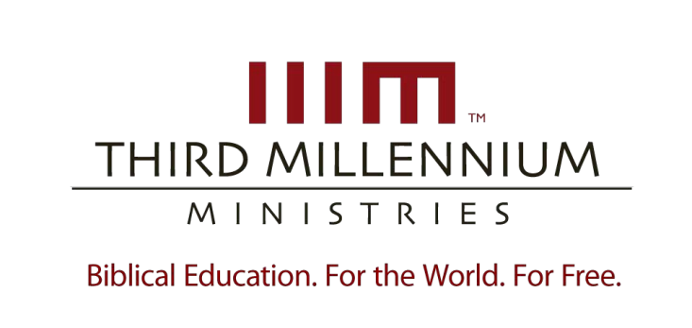

1

Kingdom
, Covenants
& Canon of the Old

Testament

Essay Questions

For videos,
manuscripts,

and other resources, visit Third Millennium Ministries at thirdmill.org
.

L
ESSON
O
NE

W
HY
S
TUDY THE
O
LD
T
ESTAMENT
?

Essay Questions

- Name and describe two causes that create a sense of distance between us and the Old Testament.

- Describe three kinds of distance we commonly find between us and the Old Testament.

- Explain the relationship between Jesus’ teaching and the teaching of the Old Testament.

- How does Paul’s teaching affirm the ongoing value of the Old Testament?

- What should we learn from the teachings of Jesus and Paul about the relevance of the Old Testament in the modern world?

- Describe the significant challenge do we face as we try to understand and apply the Old Testament to our lives.

- Describe the connections that make it possible for us to apply the teachings of the Old Testament in our contemporary world.

- Describe three significant developments that took place between the period of the Old Testament and period of the New Testament.

1

Kingdom
, Covenants
& Canon of the Old

Testament

Essay Questions

For videos,
manuscripts,

and other resources, visit Third Millennium Ministries at thirdmill.org
.

L
ESSON
T
WO

T
HE
K
INGDOM OF
G
OD

Essay Questions

- Describe the Old Testament’s teaching on God’s complete and unchanging sovereignty.

- In what ways does the Bible speak of God’s kingdom developing?

- Describe how the primeval history first established the place of God’s kingdom.

- Describe God’s intended role for people in the establishment and preparation of God’s kingdom.

- Briefly sketch the progress of God’s kingdom during the primeval period.

- What was the place of the kingdom during the days of ancient Israel?

- How did the people of ancient Israel establish and prepare God’s kingdom?

- Describe the progress of God’s kingdom during the time of ancient Israel.

- What does the New Testament say about the place of God’s kingdom?

- How does the New Testament describe the people of the kingdom of God?

- Explain the New Testament’s teaching about the progression of God’s kingdom.

1

Kingdom
, Covenants
& Canon of the Old

Testament

Essay Questions

For videos,
manuscripts,

and other resources, visit Third Millennium Ministries at thirdmill.org
.

L
ESSON
T
HREE

D
IVINE
C
OVENANTS

Essay Questions

- What recent archaeological discoveries can help us understand biblical covenants?

- What insights can recent archaeological discoveries give us into biblical covenants?

- How did the universal covenants move God’s kingdom purposes forward?

- How did the national covenants move God’s kingdom purposes forward?

- How does the new covenant move God’s kingdom purposes forward?

- How are covenant dynamics expressed in the universal covenants?

- How are covenant dynamics expressed in Israel’s national covenants?

- How are covenant dynamics expressed in the new covenant?

- Describe the divisions of humanity within all types of divine covenants.

- How are the dynamics of covenants applied to these different groups of people?

1

Kingdom
, Covenants
& Canon of the Old

Testament

Essay Questions

For videos,
manuscripts,

and other resources, visit Third Millennium Ministries at thirdmill.org
.

L
ESSON
F
OUR

T
HE
C
ANON OF THE
O
LD
T
ESTAMENT

Essay Questions

- How is the use of the Canon as a mirror justified by the character of Scripture and biblical example?

- Describe the three common focuses of thematic analysis.

- How do the character of Scripture and the biblical example provide a basis for using the Canon as a window?

- How do synchronic snapshots and diachronic traces function? Why are they useful?

- How do the character of Scripture and biblical examples provide the basis for viewing the Canon as a picture?

- Describe the value of a three-fold focus on the writer, audience and document in literary analysis.

