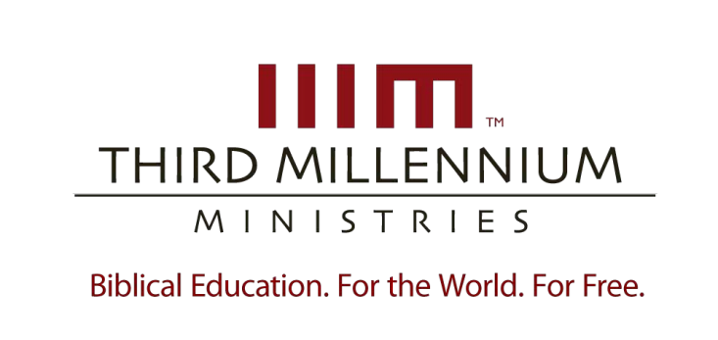

1

Building Your
Theology

Essay Questions

For videos,
manuscripts,

and other resources, visit Third Millennium Ministries at thirdmill.org
.

L
ESSON
O
NE

W
HAT IS
T
HEOLOGY
?

Essay Questions

- Briefly state the four definitions of “theology” provided by Aquinas, Hodge, Ames and Frame.

- Describe the two tendencies or perspectives most people have when approaching the study of theology.

- Contrast the relative strengths and weaknesses an academic orientation and a life orientation.

- Describe the three primary goals of theology.

- In what ways are the three primary goals of theology interdependent?

- How should a person prioritize the three goals of theology?

- Describe the options available to systematic theologians in terms of topics and goals.

- What selections are represented in a typical seminary curriculum, and why are these selections valuable?

1

Building Your
Theology

Essay Questions

For videos,
manuscripts,

and other resources, visit Third Millennium Ministries at thirdmill.org
.

L
ESSON
T
WO

E
XPLORING
C
HRISTIAN
T
HEOLOGY

Essay Questions

- Why can it be hard to define “Christian theology”?

- Why should we be satisfied with a working definition that accords with the Apostle’s Creed?

- What accounts for the unity of the body of Christ? Why it is our responsibility to promote theological unity within the body of Christ?

- What accounts for the diversity within the body of Christ?

- As we survey Christian theology, why is it important to maintain a balanced perspective regarding theological unity and diversity?

- What is “tradition”?

- Describe the three tendencies that theological traditions tend to follow.

- How can self-awareness and awareness of others impact and affect our theological traditions?

- Give a brief historical sketch of the development of Reformed theology, highlighting significant historical events.

- What are the theological tendencies of the Reformed tradition?

7

- Summarize each of the four distinctives of the Reformed tradition.

1

Building Your
Theology

Essay Questions

For videos,
manuscripts,

and other resources, visit Third Millennium Ministries at thirdmill.org
.

L
ESSON
T
HREE

R
ELYING ON
R
EVELATION

Essay Questions

- What is general revelation? What does it teach us?

- What is special revelation? What does it teach us?

- Describe the interconnections between general and special revelation in terms of their overlap and necessity.

- Why is it important to derive our theology from revelation?

- How does sin hinder our understanding God’s general and special revelation?

- How does the Holy Spirit help us understand God’s special and general revelation?

- How should we handle apparent conflicts between general and special revelation?

- What does it mean to say that theological conclusions are analogue rather than binary?

- Describe the process of deferring to exegesis, community, and Christian living. Why is this process helpful?

- How can we assign proper levels of confidence to our various beliefs?

1

Building Your
Theology

Essay Questions

For videos,
manuscripts,

and other resources, visit Third Millennium Ministries at thirdmill.org
.

L
ESSON
F
OUR

A
UTHORITY IN
T
HEOLOGY

Essay Questions

- Describe the posture the medieval church took regarding the authority of Scripture in regards to inspiration, meaning and obscurity.

- Explain how medieval theologians understood the authority of the church in the past and in their contemporary setting.

- What were the effects of the medieval period’s view of the authority of Scripture and the church?

- Describe the posture the early Protestants took regarding the authority of Scripture in regards to inspiration, meaning and obscurity.

- Explain how the early Protestants understood the authority of the church in the past and in their contemporary setting.

- What were the effects of the early Protestants’ view of the authority of Scripture and the church?

- Describe the posture of contemporary Protestants regarding the authority of Scripture in regards to inspiration, meaning and obscurity.

- Explain how contemporary Protestants understand the authority of the church in the past and our contemporary setting.

- What are the effects of the contemporary Protestant view of the authority of Scripture and the church?

