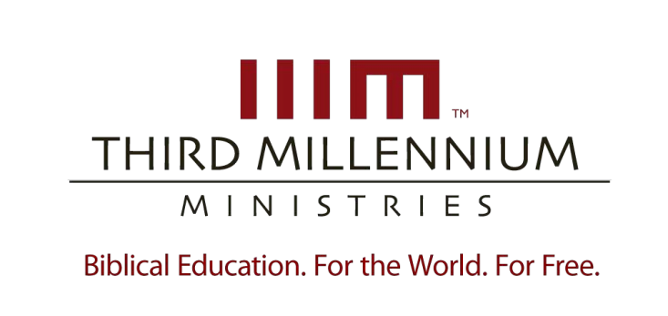

1

Building Systematic
Theology

Essay Questions

For videos,
manuscripts,

and other resources, visit Third Millennium Ministries at thirdmill.org
.

L
ESSON
O
NE

W
HAT IS
S
YSTEMATIC
T
HEOLOGY
?

Essay Questions
- Describe the contours of systematic theology in terms of its commitments to scriptural truth, logical coherence and traditional emphases.

- Describe the contours of New Testament theology in terms of its diversity, pastoral character, genres and framework.

- In what ways is systematic theology like New Testament theology?

- In what ways is systematic theology different from New Testament theology?

- Why and how did authentic Christian theology change to meet the challenges of ministry to the Gentiles during the Patristic period?

- Describe the theological movement of Scholasticism, and its use of Aristotelian logic.

- Describe the three stages of Protestant theology in terms of the early Reformers, the classical confessions and modern systematics.

- What similarities are there between the way theology was done in the Patristic, Medieval and Protestant periods?

- Describe how systematic theology enhances and hinders the three aspects of Christian living.

- Describe how systematic theology enhances and hinders the three aspects of interaction in community.

- Explain how systematics enhances and hinders exegesis.

- How can we successfully navigate the dangers of systematic theology in order to take advantage of its values?

1

Building Systematic
Theology

Essay Questions

For videos,
manuscripts,

and other resources, visit Third Millennium Ministries at thirdmill.org
.

L
ESSON
T
WO

T
ECHNICAL
T
ERMS IN
T
HEOLOGY

Essay Questions
- Briefly explain what theological technical terms are, and how they are used.

- Explain how terms and concepts relate to each other in general language and in Scriptural language.

- Explain why systematic theologians need technical terms in systematic theology.

- Explain how technical terms serve as the basic building blocks of systematic theology.

- How does an understanding of technical terms help us in building systematic theology?

- Explain the three ways in which systematic theologians form technical terms from Scripture.

- Explain the three ways in which systematic theologians form technical terms from extra-biblical language.

- Why is it important to understand how theological technical terms are created?

- Describe how the special language of systematic theology can both enhance and hinder Christian living.

- Describe how technical terms can both enhance and hinder interaction in community.

- Describe how technical terms can both enhance and hinder the exegesis of Scripture.

- Given the potential hindrances created by theological technical terms, why is it still important to use them?

1

Building Systematic
Theology

Essay Questions

For videos,
manuscripts,

and other resources, visit Third Millennium Ministries at thirdmill.org
.

L
ESSON
T
HREE

P
ROPOSITIONS IN
S
YSTEMATICS

Essay Questions

- Describe the four aspects that form the definition of propositions in systematic theology.

- Explain why the process of building theology with propositions is legitimate.

- Explain the place theological propositions have within the process of building systematic theology.

- How does an understanding of propositions help us build systematic theology?

- Explain how Systematicians form propositions from their interaction with philosophy.

- Explain how Systematicians overcome the challenges of forming propositions from the Bible.

- Why is it important to interact with both philosophy and Scripture when forming theological propositions?

- Describe how Christian living enhances and hinders the formation of theological propositions.

- Describe how interaction in community enhances and hinders the formation of theological propositions.

- Describe how exegesis enhances and hinders the formation of theological propositions.

- How does a better understanding of the dangers of propositions in theology help us benefit from propositions in theology?

1

Building Systematic
Theology

Essay Questions

For videos,
manuscripts,

and other resources, visit Third Millennium Ministries at thirdmill.org
.

L
ESSON
F
OUR

D
OCTRINES IN
S
YSTEMATICS

Essay Questions
- Describe doctrinal statements in terms of topics, synthesis and explanations of doctrinal statements.

- Explain how Jesus and Paul gave legitimacy to the practice of creating doctrines.

- Describe the way in which doctrines are shaped by both positive and negative goals.

- Describe the place doctrines have within systematic theology.

- Explain how doctrines are simply ways in which we summarize what we believe about the Bible.

- Explain how Systematicians use biblical support to substantiate the formation of theological doctrines.

- Briefly describe the use of logical support in the formation of systematic theology in terms of authority, deductive implications and inductive certainty.

- Explain the importance of using both logic and Scripture in formulating theological doctrines.

- Explain how theological doctrines both enhance and hinder Christian living.

- Explain how theological doctrines both enhance and hinder interaction in community.

- Explain how theological doctrines both enhance and hinder exegesis of Scripture.

- How does the awareness and proper navigation of the inherent dangers of forming theological doctrines help us to reap the enhancements that theological doctrines provide?

